CSI Lab AC: Spring 2020

**Dev Singh**

Working for the Learning Company you often create programs helpful for students. Your colleague was working on a grades program that allows students to input test scores and calculate their average for as many classes as they would like. She went on vacation and the program must be completed. While much of the code is completed, she is in the test & debug stage and there are still a few issues to be resolved. (Also, it needs to be formatted so that it displays 2 decimal places when outputting the final answer - you may need to look up how to do that)

You have been tasked with finishing the project, yet you cannot rewrite the whole program, nor can you change the variable names (unless there is a syntax error) as this is just one piece of a much larger program. That also means that the code needs to be appropriately placed in functions to be imported into a larger program.

The program should be able to execute smoothly and regardless of the inputs should continue to function, here are some sample test cases:

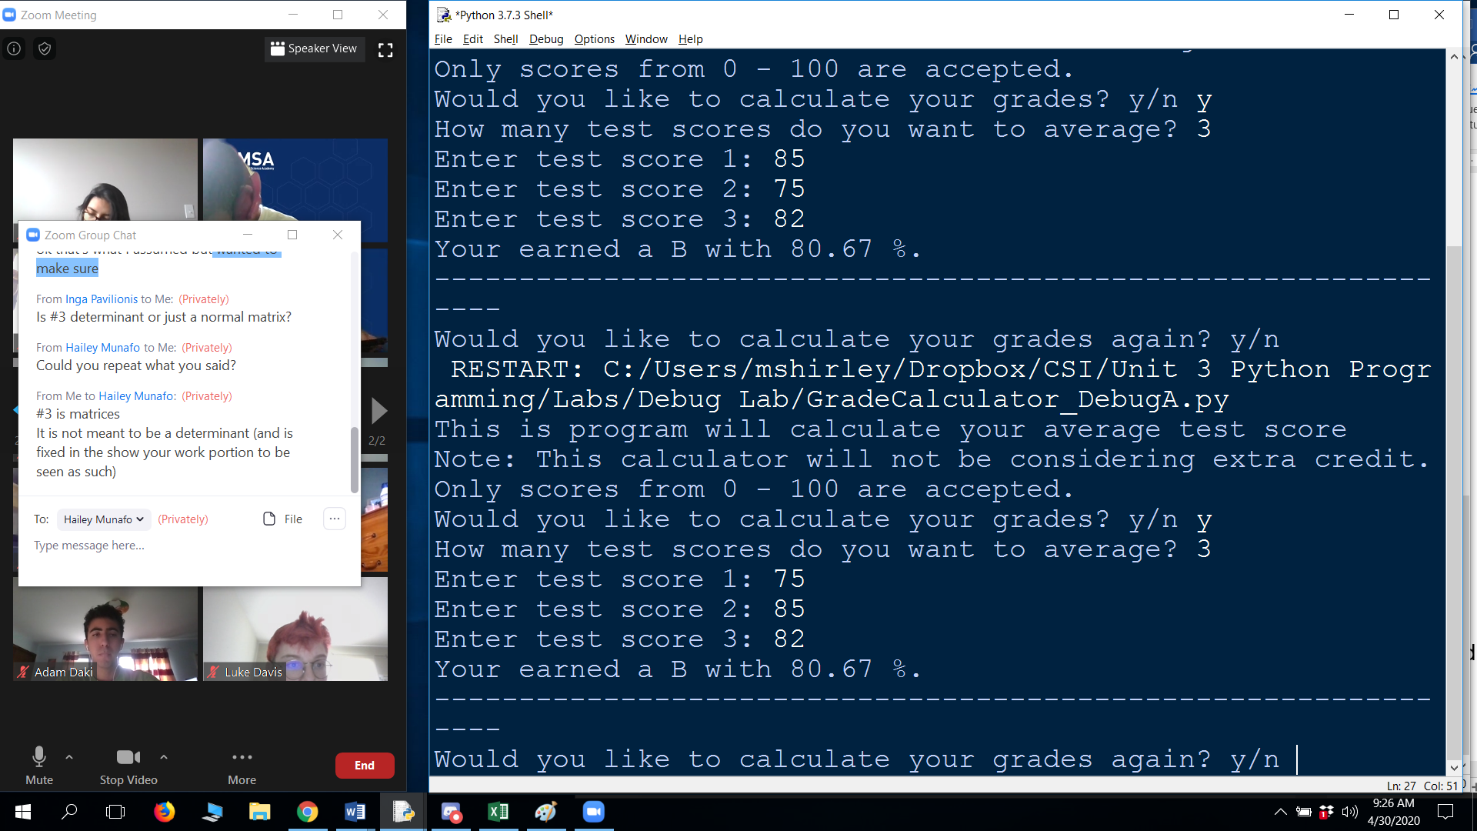

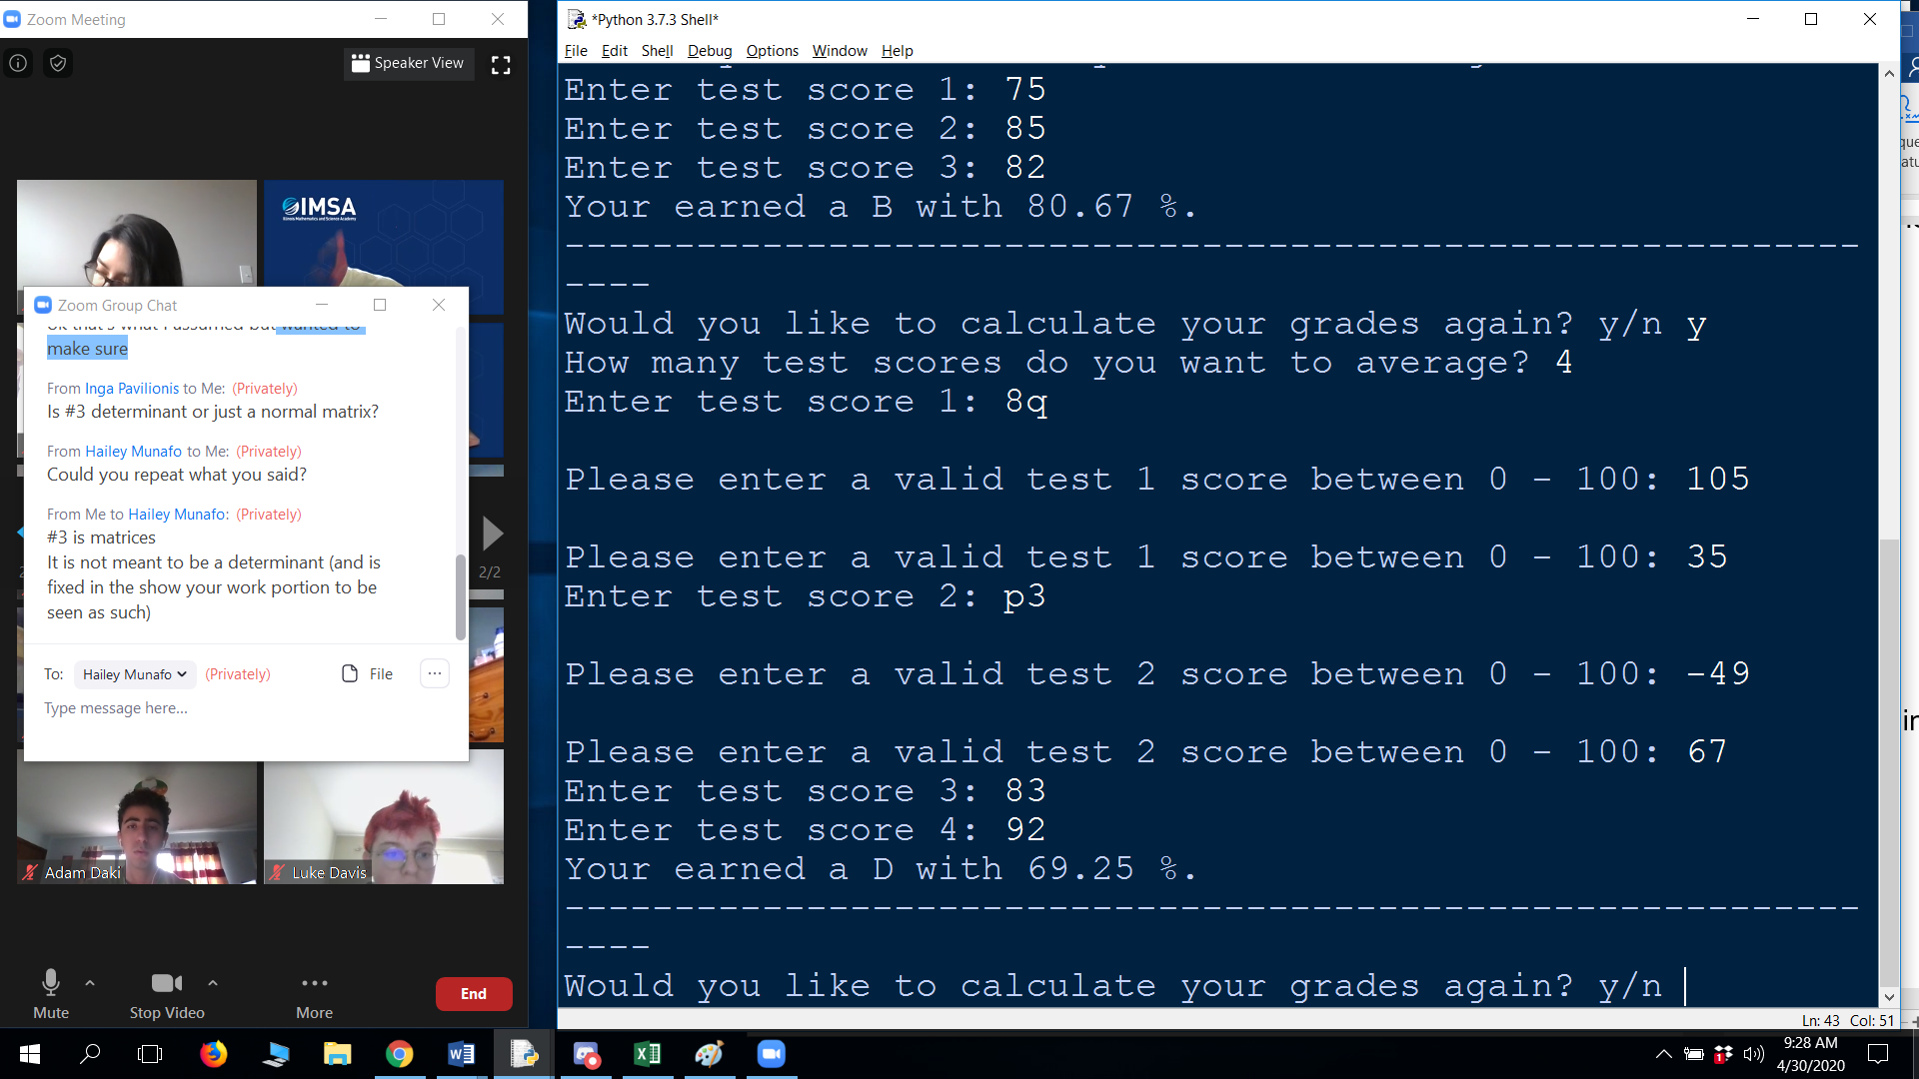

**Directions:**

**Part 1:** Add comments for each function – Listing the comments here would be best. (Only one comment is needed per function, and that is to explain the purpose of that function – it may help you in thinking about its purpose and looking for errors).

def directions():

*# output the directions to the user*

def inputNumberTests():

*# get the number of test scores*

def validateInput(numScores):

*# Get valid test scores that fit within the bounds.*

def calculatePercent(scoreList, numTests):

*# calculate the average percent*

def assignGrade(percent):

*# turn a percent into a letter grade*

def main():

*# driver code to run all the functions in the correct order.*

**Part 2:** Find all the errors (bugs) in the code and resolve any issues, list the lines of code and their corrections below: *(Remember, some errors will cause the program not to run, others will cause it the outputs to be incorrect)*

**Error #1:**

Original Code:

for i in range(1, numScores):

Modified Code:

for i in range(1, numScores + 1):

Explanation of Error:

# range does not include the last number, so go +1

**Error #2:**

Original Code:

     percent = (sum(scoresList) / numTests)

Modified Code:

     percent = (sum(scoreList) / numTests)

Explanation of Error:

# misspelled variable

**Error #3:**

Original Code:

     return numTests # return the percent not the number of tests

Modified Code:

     return percent # return the percent not the number of tests

Explanation of Error:

# return the percent not the number of tests

**Error #4:**

Original Code:

     elif percent >= 80 and percent <= 89: # fractional needs to match to a B

Modified Code:

     elif percent >= 80 and percent < 90: # fractional needs to match to a B

Explanation of Error:

# fractional needs to match to a B

**Error #5:**

Original Code:

     response = response.lowercase() # not .lowercase(), just .lower()

Modified Code:

     response = response.lower() # not .lowercase(), just .lower()

Explanation of Error:

# not .lowercase(), just .lower(). .lowercase() is not a function

**Error #6:**

Original Code:

print("Your earned", letterGrade, "with", percent,"%.")

Modified Code:

          print("Your earned", letterGrade, "with", "{:.2f}".format(percent),"%.") #truncate to two decimal points without introducing floating point errors.

Explanation of Error:

#truncate to two decimal points without introducing floating point errors.

**Error #7:**

Original Code:

answer = input("Would you like to calculate your grades again? y/n ")

Modified Code:

          response = input("Would you like to calculate your grades again? y/n”)

Explanation of Error:

# should assign to response and not to answer to finish the loop

**Error #8:**

Original Code:

input("Thank you for playing. Press any key to end.")

Modified Code:

     input("Thank you for playing. Press enter key to end.")

Explanation of Error:

# you can't press any key, you have to press enter.